This appendix sets out the technical approach for SkyDrive. It first describes the technical concept and the features of the integrated propulsion subsystem, then the approach to delivery and the work-package structure, the detail of each work package, and the schedule and milestones. The detailed cost breakdown is provided in the Costs appendix (Q16), the technical risks in the Risks appendix (Q14) and the underlying innovations in the Innovation appendix (Q13).
12.1. Technical Concept and Solution: SkyDrive develops an integrated 100 kW class high-voltage electric propulsion subsystem designed specifically for hybrid aerospace applications, where battery-only architectures are constrained by energy density and mass and a battery plus hydrogen-fuel-cell hybrid offers a more scalable, certification-aligned pathway for regional, sub-regional and advanced light aircraft. The central technical idea is to treat the powertrain not as a set of separately sourced parts but as a single, jointly certifiable subsystem in which the machine, the drive, the gearbox, the thermal management and the control are co-designed, as shown in Figure 1. The subsystem combines a high-speed six-phase motor operating at 1 kV and 18,000 rpm, a fault-tolerant multilevel inverter, a high-speed step-down gearbox and an integrated control and thermal-management architecture; external energy storage is out of scope and bought in, so the project concentrates on the motor and power-electronics integration that determines power density, efficiency and fault tolerance.
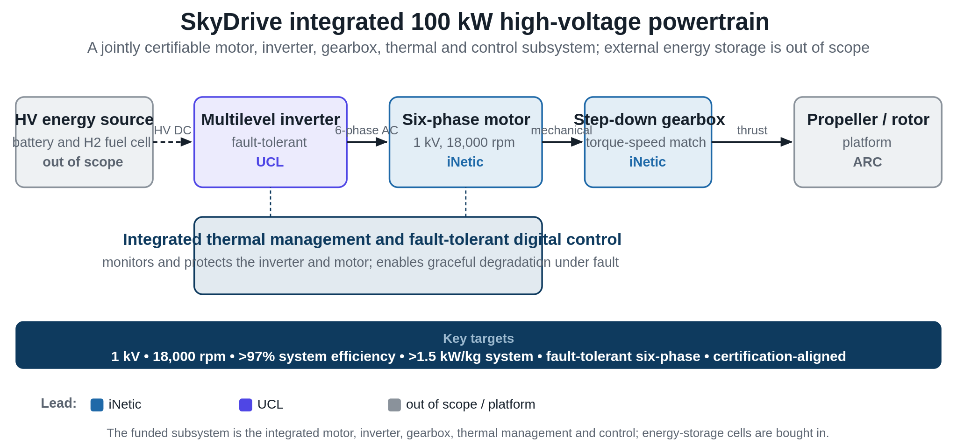
Figure 1. The SkyDrive integrated powertrain: a co-designed, jointly certifiable motor, inverter, gearbox, thermal and control subsystem.
Several features distinguish the solution. The six-phase machine provides inherent redundancy, so that the loss of a phase degrades performance gracefully rather than causing failure, which is central to aerospace fault tolerance. High-voltage operation at 1 kV reduces current and cabling mass for a given power, while the multilevel inverter limits voltage stress and partial discharge and enables fault reconfiguration. The integrated thermal management sustains continuous high-power operation, and the fault-tolerant digital control coordinates the machine and drive and manages degraded modes. The resulting targets are demanding and specific: continuous high-power operation, a system-level power density above 1.5 kW/kg for the integrated motor and inverter (with active-material density above 15 kW/kg), system efficiency above 97%, defined fault tolerance under specified failure modes, and compliance-aligned validation evidence. By embedding certification considerations within the subsystem design and test planning from the outset, the project generates the artefacts that reduce downstream integration and approval risk for OEMs.
The programme matures this integrated motor-drive assembly from TRL3 to TRL6 through laboratory validation, hardware-in-the-loop testing, environmental stress testing and integrated operation on ARC Aero Systems' flight-representative Pegasus platform, with a defined progression to the nine-seat Linx P9. The architecture is deliberately modular, so the same motor and inverter building blocks scale to higher power by adding phase modules and stacking inverter cells rather than by redesign. The further developments required for megawatt-class variants, principally higher-voltage insulation coordination, multi-module thermal balancing and parallel-inverter control, are identified at the outset and are directly de-risked by the 100 kW demonstration, establishing a credible route from the Linx P9 towards larger regional platforms. The consortium brings together complementary UK capability across the propulsion value chain: iNetic leads motor design, gearbox integration and aerospace-grade manufacturing; UCL contributes multilevel power electronics, control architecture and electro-thermal modelling; ARC provides system integration and flight-representative validation; and Eaton participates as a non-funded Tier-1 adviser on certification, industrialisation readiness and system safety.
12.2. Approach to Delivery and Work-Package Structure: To deliver this, the work is organised into five technical work packages, WP1 to WP4, together with an overarching project-management work package, WP0. The work packages are interdependent: the motor (WP1) and the drive (WP2) are developed in parallel but share a motor-drive interface that must be matched in torque-speed and electrical terms; both feed their hardware into system integration and validation (WP3); and the validated subsystem and its data feed exploitation (WP4). Figure 2 shows these relationships and how the partners are involved, with iNetic, UCL and ARC each leading the work packages aligned to their capability and Eaton advising across all of them. Project control uses iNetic's established life-cycle management methodology, xRL and PROLaunch, spanning technical, manufacturing and commercial readiness, with weekly, monthly and quarterly reviews, robust risk and issue management, and technical reviews at each TRL milestone. Development follows a model-led, test-validated route in which the multi-physics models established at lower TRL are progressively verified against hardware. The approach builds directly on the partners' prior and parallel programmes, including iNetic's high-speed machine and gearbox work, UCL's multilevel-converter research and ARC's flight-representative test campaigns, so that proven methods and lessons learned are carried into SkyDrive. The project has no critical dependency on any external parallel technology development, which keeps the principal delivery risks within the consortium's direct control.
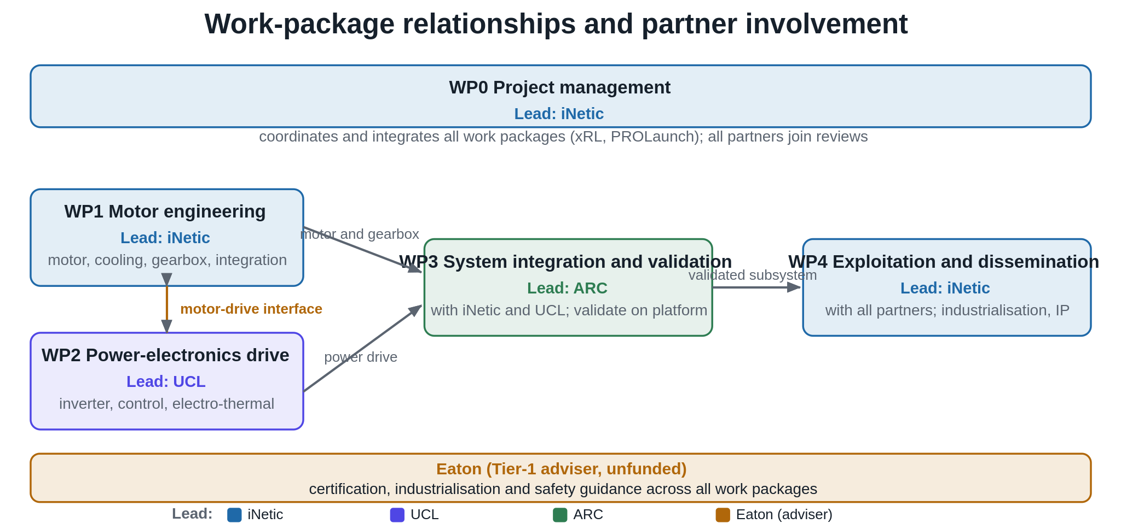
Figure 2. Work-package relationships and partner involvement: lead partners, interdependencies and the Tier-1 adviser role.
12.3. Work Package Detail: The objective, approach and key deliverables of each work package are described below.
WP0 Project Management (iNetic) coordinates the project under an experienced iNetic project manager working with the Principal Investigator, who holds technical leadership, using iNetic's xRL and PROLaunch life-cycle tools, robust risk and issue management and regular technical reviews at TRL milestones, with the consortium meeting weekly, monthly and quarterly. Its deliverables are the quarterly review reports and the schedule, deliverable, milestone, risk-register and issue-log updates that support quarterly progress reviews with the monitoring officer.
WP1 Six-Phase Motor Engineering (iNetic) designs, builds and verifies the flight-representative motor with integrated cooling and a step-down gearbox, advancing from validated models to TRL6. Electromagnetic and mechanical optimisation (WP1.1) performs multi-physics optimisation of the six-phase machine for power density, efficiency and structural integrity at 18,000 rpm; an advanced integrated cooling system (WP1.2) sustains stable temperatures during continuous high-power operation; a high-speed step-down gearbox (WP1.3), derived from the torque-speed envelope defined in WP1.1, enables efficient torque-speed matching to the platform; and hardware integration (WP1.4) assembles and bench-tests the subsystems. The key deliverable is the manufactured and validated motor, cooling and gearbox assembly, and WP1 defines the torque-speed envelope and motor interface on which WP2 and WP3 depend.
WP2 Fault-Tolerant Power-Electronics Drive (UCL) designs, optimises and integrates a multilevel, fault-tolerant drive tailored to the six-phase motor. Topology definition and control optimisation (WP2.1) assesses candidate topologies, including neutral-point-clamped and flying-capacitor arrangements, for above 1 kV operation with reduced dv/dt and common-mode stress, and develops six-phase modulation and digital control that maintain balanced power sharing and fault tolerance under single-phase or device-failure scenarios; electro-thermal design and cooling (WP2.2) quantifies losses and reliability margins and stabilises junction temperatures; and hardware build and readiness verification (WP2.3) consolidates the semiconductor modules, capacitors, busbars and cooling into a fabricated drive verified for electrical, thermal and EMI compliance. The key deliverable is the fully fabricated, readiness-verified drive unit, and WP2 interfaces with the WP1 motor design and feeds WP3.
WP3 System Integration and Experimental Validation (ARC Aerosystems) integrates the motor-gearbox and drive into the flight-representative propulsion subsystem and validates it on the SkyDrive platform under aerospace-representative duty cycles, including environmental, thermal and transient-load testing, against the airworthiness-aligned evidence requirements set during design. The key deliverable is the integrated propulsion subsystem validated on the platform, which provides the TRL6 evidence base; WP3 consumes the hardware delivered by WP1 and WP2 and generates the data that underpins later certification. Validation spans fault-injection tests that confirm graceful degradation under phase and device loss, thermal-endurance and altitude-representative environmental cycles, and EMI characterisation, producing a reusable, airworthiness-aligned evidence package that directly de-risks downstream OEM integration. The mass and efficiency gains demonstrated in this work feed the aircraft-level range and payload benefit quantified in the Benefits appendix (Q11), establishing a clear line of sight from subsystem performance to aircraft-level outcome.
WP4 Exploitation and Dissemination (iNetic) delivers the industrialisation and feasibility assessment and the exploitation strategy and IP-protection framework, and disseminates project outcomes through publications and targeted industry engagement. Its key deliverables are the industrialisation and feasibility assessment report and the exploitation strategy and IP-protection framework; the route to market and wider benefits are detailed in the Results and Benefits appendices (Q10 and Q11).
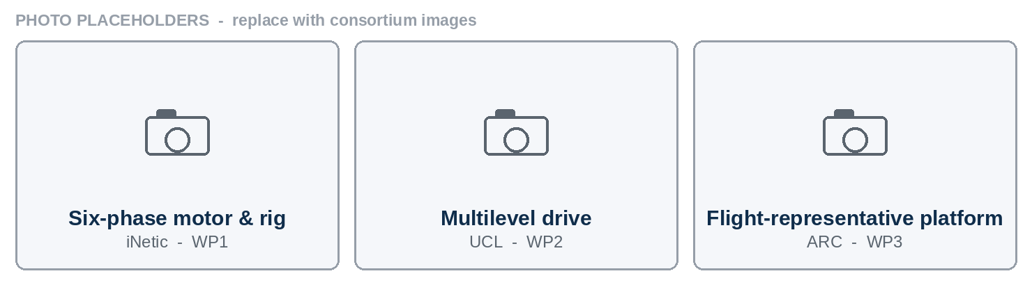
Photographs of the build streams: (left) iNetic six-phase motor and dynamometer rig; (centre) UCL multilevel power-electronics drive; (right) ARC flight-representative platform. Placeholders to be replaced with consortium images.
12.4. Schedule and Milestones: The programme runs for 36 months. Motor and power-electronics development proceed in parallel through the first two years, feeding system integration and validation from the mid-point, with exploitation concentrated in the final year and project management spanning throughout; the integrated subsystem reaches TRL6 by around 2029. The TRL-gated milestones are summarised in Table 1, and the full work plan is shown in Figure 3.
Table 1. Key project milestones
Milestone | Description | Target
M1 | Requirements and baseline designs frozen across the motor and drive | Month 6
M2 | Motor and drive detailed designs verified by analysis (TRL4 to 5) | Month 12
M3 | Motor, gearbox and drive hardware manufactured and bench-tested | Month 20
M4 | Integrated propulsion subsystem assembled | Month 30
M5 | Integrated subsystem validated on the SkyDrive platform (TRL6) | Month 36
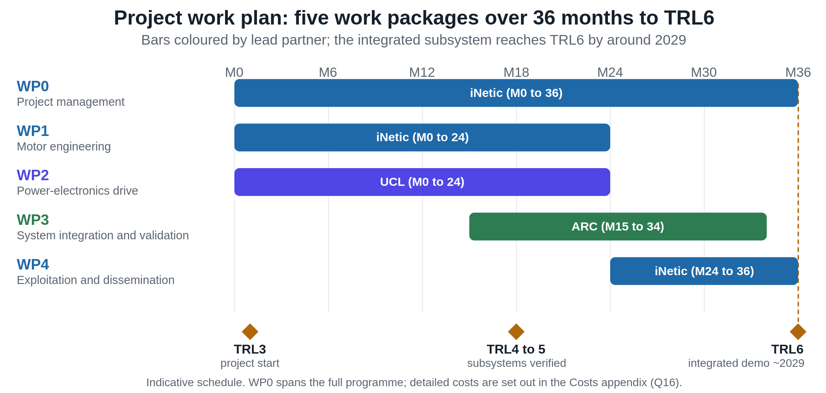
Figure 3. SkyDrive project work plan: five work packages over 36 months, reaching TRL6 by around 2029.
Taken together, the technical approach starts from a clearly defined integrated subsystem and a set of demanding, specific targets, and delivers them through a structured work plan in which co-designed motor and power-electronics development, mid-programme system integration and a final-year exploitation phase are coordinated by a milestone-gated management approach, advancing the subsystem from TRL3 to a validated TRL6 demonstration.

